Assignment 7-Output

->OLAP OPERATIONS

1.**DRILL DOWN OPERATION:**

**BEFORE-(ORIGINAL TABLE)**

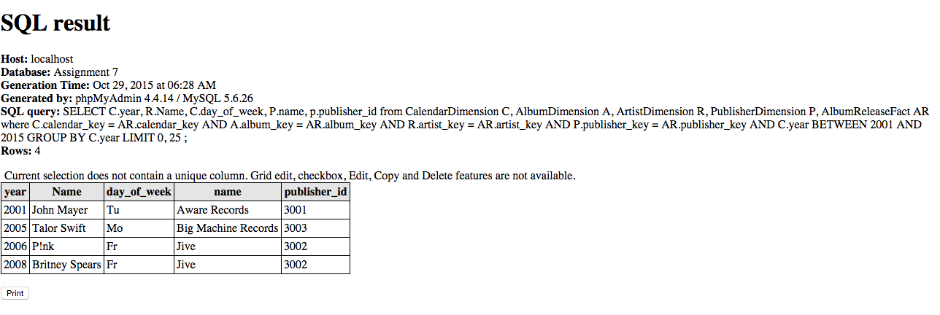

**AFTER-DRILL DOWN OPERATION**

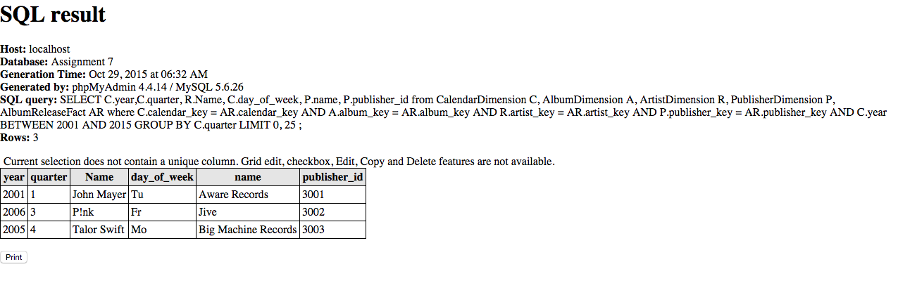

**AFTER-DRILL DOWN OPERATION**

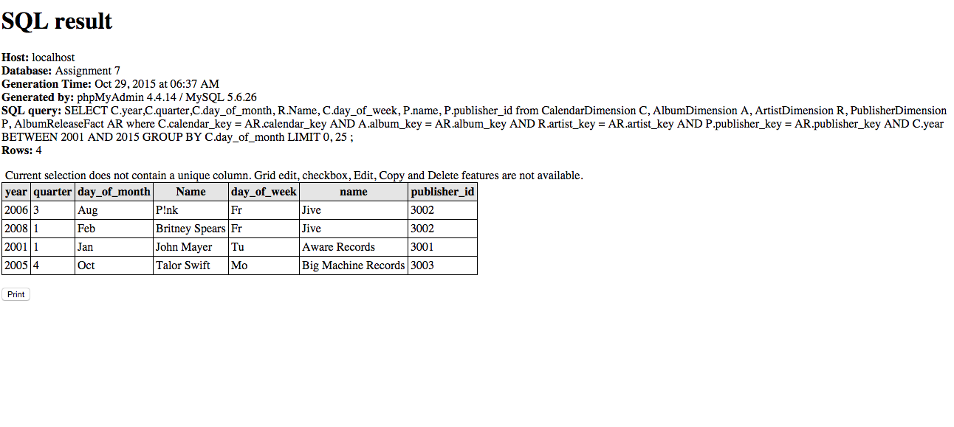

**2.DRILL UP OPERATION:**

**->BEFORE(ORIGINAL TABLE)**

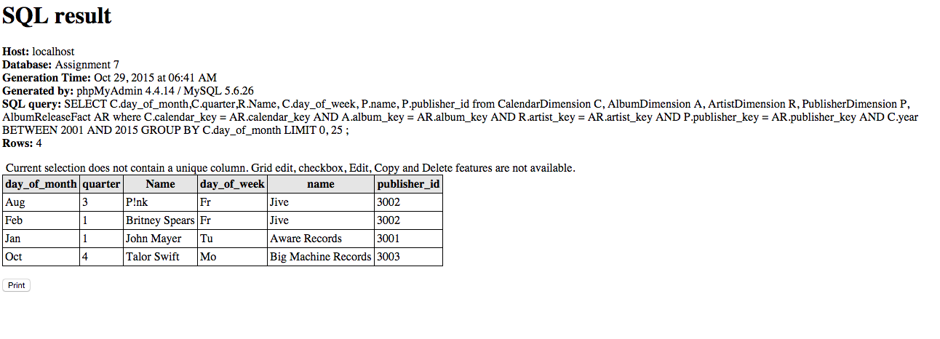

**->AFTER(DRILL UP OPERATION)**

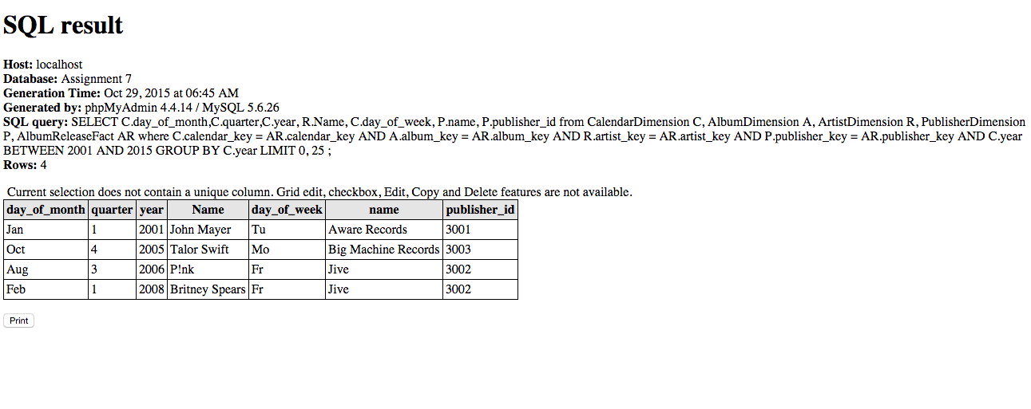

**3.SLICE OPERATION**

**->BEFORE(ORIGINAL TABLE)**

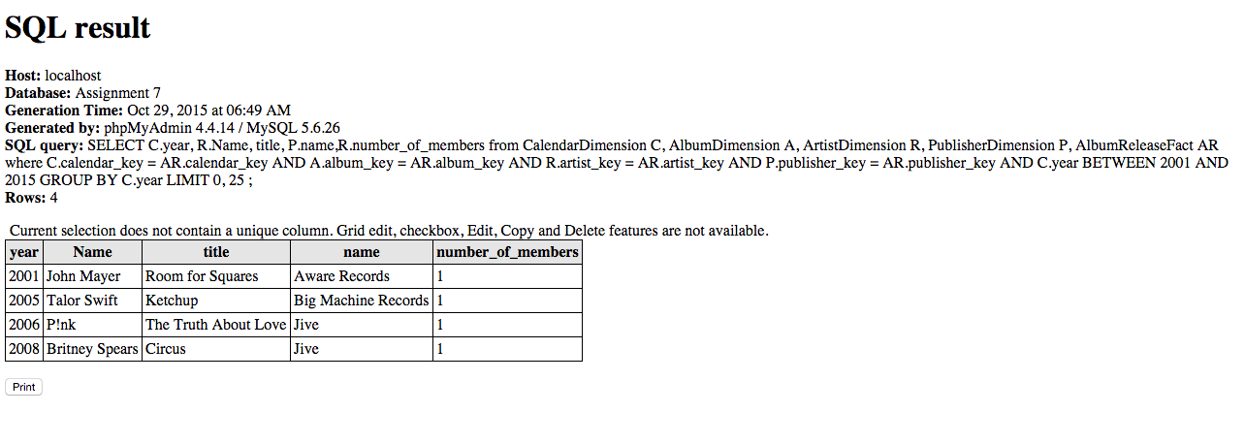

**->AFTER(SLICE OPERATION)**

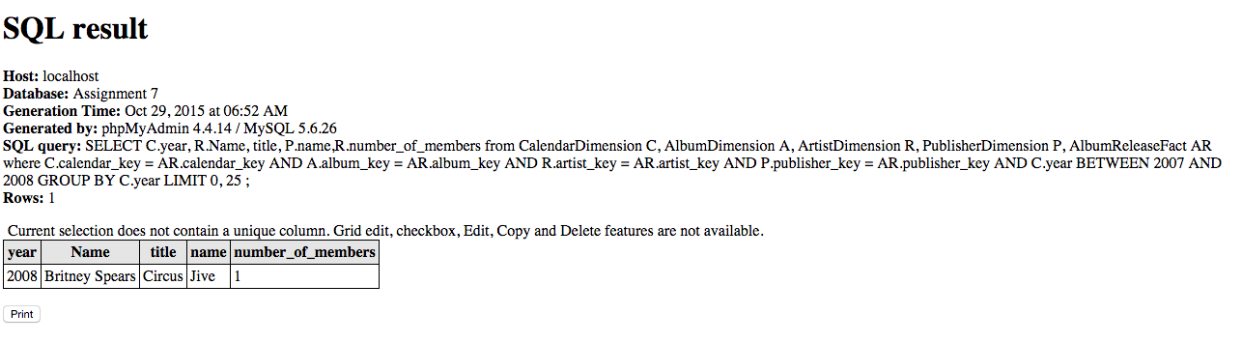

**4.DICE OPERATION**

**->BEFORE(ORIGINAL TABLE)**

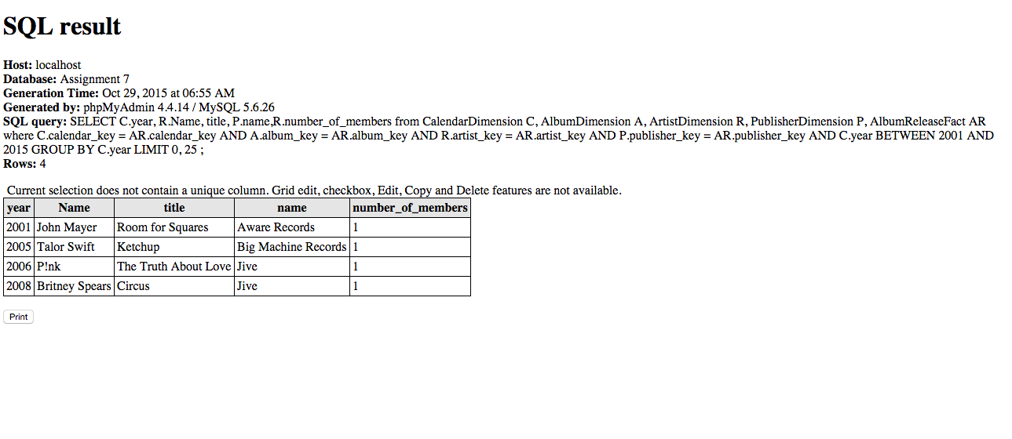

**->AFTER(DICE OPERATION)**

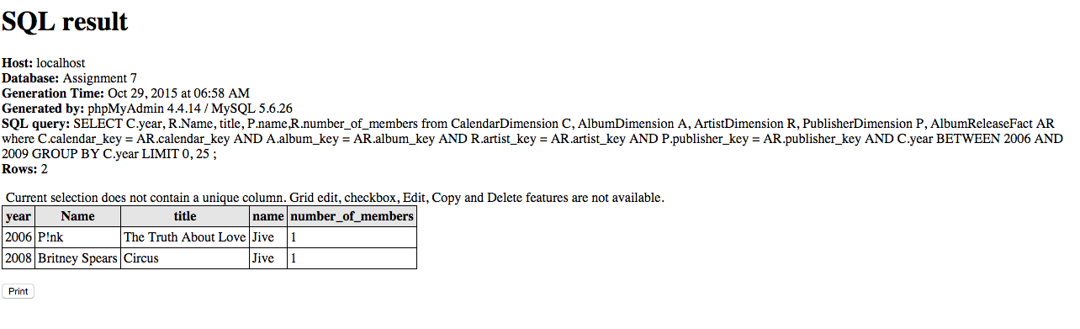

**5. PIVOT OPERATION**

**BEFORE(ORIGINAL TABLE)**

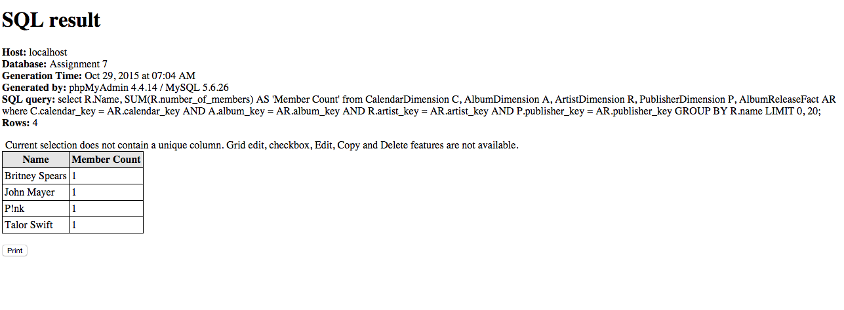

**AFTER(PIVOT OPERATION)**

